**CONTENTS**

**Chapter 1: Introduction**

* 1. [Age-related macular degeneration](https://www.medicinenet.com/image-collection/age-related_macular_degeneration_picture/picture.htm" \t "_blank)(ARMD)…………………………………..
  2. Dry ARMD…………………………………………………………………....
  3. Wet ARMD……………………………………………………………………
  4. Data Used……………………………………………………………………..
  5. Symptoms of Macular Degeneration……………………………………………
  6. Causes of Macular Degeneration……………………………………………..
  7. Preventing Macular Degeneration…………………………………………….

**Chapter 2: Problem Statement and Proposed Solution**

1. Problem Statement………………………………………………………………..
2. Existing System…………………………………………………………………...
3. Proposed Solution…………………………………………………………………

2.3.1 Convolution Neural Network……………………………………………….

2.3.2 Inception V3…………………………………………………………………

2.3.3 Architecture………………………………………………………………….

2.3.4 Transfer Learning……………………………………………………………

2.3.5 Flask…………………………………………………………………………

**Chapter 3: Literature Survey**

1. Literature survey challenges……………………………………………………….

**Chapter 4: Architecture and Design**

1. Graphical User Interface………………………………………………………….
2. Pre-Processing…………………………………………………………………….
3. Pretrained Model Weight…………………………………………………………
4. Create CNN model………………………………………………………………..
5. Compile CNN model……………………………………………………………..
6. Training model……………………………………………………………………
7. Classifying images with CNN…………………………………………………….
8. Output Image………………………………………………………………………

**Chapter 5: Implementation**

1. Development Requirements ………………………………………………………
   * 1. Hardware Requirements…………………………………………………...
     2. Software Requirements……………………………………………………
2. Loss………………………………………………………………………………..
3. Accuracy…………………………………………………………………………..

**Chapter 6: Result**

**Chapter 7: Conclusion**

**Chapter 8: References**

**Chapter 9: Appendix**

**ABSTRACT**

Using automation to find macular degeneration in the eye with the help of oct images, we researched different ai, ml processing techniques which might be used to discover armd using oct images. armd can cause blindness,if it not found in early stages. It can be curable if it found out in early stages,some of the early symptoms of armd are drusen deposition,macular degeneration,etc. Manually labelling of oct images is labour intensive and is vulnerable to human blunders, right here ml and ai models can help in early and rapid detection of the early stages of the armd which can then be used to treat the person from armd. Even though the armd can't be completely cured, an accurate early detection can help us to prevent the disease at early stage. However, manual detection of ARMD is very diffcult task so,In this project we are going to build a ml model which takes oct images as a dataset and predicts wheher the image is normal ,wet or dry armd

**1. INTRODUCTION**

**1.1 [Age-Related Macular Degeneration](https://www.medicinenet.com/image-collection/age-related_macular_degeneration_picture/picture.htm" \t "_blank)(ARMD):**

Eye disease-onset, often as a result of 60 years of age, which gradually destroy the macula, the central portion of the retina, impairing central vision. Sometimes in the related macular degeneration (AMD or ARMD), in certain cases, the hands, the blindness of the fact that not only the center of vision is affected. However, losing a seat in the center of the retina can impair the ability to clearly see the straight-forward, and it makes it hard to read, drive, or perform other daily activities that require central vision.

The yellow spot in the center of the retina at the back of the eye. We have read, the cast of the yellow spot, where there are millions and millions of cells, which convert the light into nerve signals that travel to the brain, and to talk about what we're seeing. This is our vision. With normal central vision, which we can read, manage, and carry out other activities that require fine, sharp, direct vision.

Aging is the leading cause of age-related macular degeneration (ARMD). First of all, there are three main types of ARMD: (i) dry, (ii) wet, and (iii) is Normal. A dry HAND is the most common form of the disease that is caused by the deletion of the mobile, a retinal pigment epithelium in the macula. It usually begins with the formation of a small, pale yellowish deposits called drusen beneath the retina, which causes a macular atrophy, which is known as the annual macular degeneration. This, in turn, affect a person's vision. A wet hand, is caused by the abnormal growth of blood vessels in the retina. These vessels are known as the choroidal neovascular membrane, which breaks out in a sweat, greedy, and bleeding. In the end, it leads to scarring of the macula, or atrophic changes, which lead to severe visual disorders. Therefore, the mortality in the developed much more quickly and lead to permanent loss of vision. The year-old macular degeneration (ARMD) is usually a fatal disease that can cause blindness in the elderly, at the age of 55. ARMD is a degeneration of the macula, a small area in the retina that controls the center and a clear vision of the human eye. It is one of the most common health problems, and / or blindness in most developed countries. It has been estimated that approximately 5% of the general population, vision loss due to ARMD, and nearly 196 million people will be affected by ARMD in the year 2020, which can reach up to 288 million by 2040. Therefore, the ARMD remains a constant source of discomfort, that is our view, and the older society, and because of this has a devastating impact on patients, their families, and a cause of considerable economic burden on the economy. There are two types of ARMD: (I) the neovascular (dry), and (ii) in the neovascular (wet) form of ARMD.

**1.2 Dry ARMD**

Dry ARMD is caused by a thinning or weakening, and atrophic changes in the macula. This is the first stage of ARMD [54]. It starts from the druses, which leads to a gradual loss of vision. Dry ARMD can be divided into four phases, the non-ARMD, and on the early, intermediate, and advanced) [50].

No-ARMD Eye is classified as non-ARMD no Druze or a little bit older (5-to 15-year-old) with a smaller Druze, with no sign of other life stages of ARMD.

In the early stages: his eye is considered to be the first stage of ARMD, if a sufficient number (>15) of the small drusas, or a handful of (>

Phase: the phase of ARMD in the application of at least one large-first or a lot of medium-sized first, or if there is a geographic atrophy, which does not extend into the center of the macula (the non-central GA.).

Advanced stage: in This stage, have been developed if you have the presence of geographic atrophy, the, spread, and in the center of the macula.

**1.3 Wet ARMD**

On the other hand, a wet ARMD, is caused by the formation of abnormal blood vessels in the inner choroid, the region of the retina [54]. These vascular malformations are very subtle, and, therefore, the cause of hemorrhage in the macula, which is likely to spread into the vitreous cavity, a gel-like structure in front of the retina, and the latter ends up in scarring of the macula. Flying is not a common form of ARMD, but, surprisingly, it is responsible for 80% of the cause of ARMD part time. In addition, a manual of age is considered to be a more advanced and severe form Figure 1 shows a schematic illustration of a cross-section of a normal, clean, dry and in the wet patch on the left shoulder. It should be noted that the dry ARMD, there is a deposit of drusen, and your hands are wet may collect the liquid.

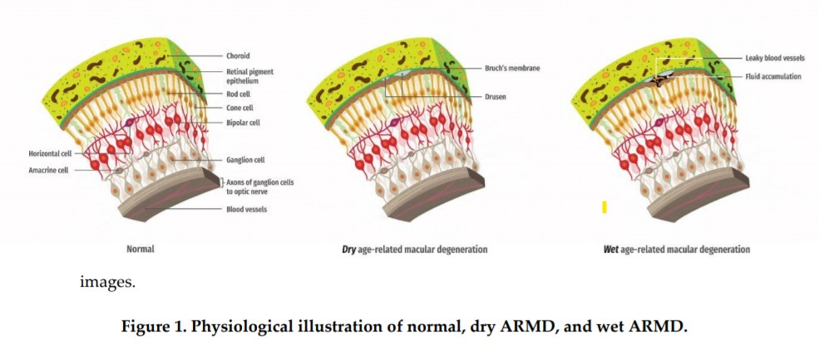

The different types of ARMD can be diagnosed with the help of the visual, the eye fundus. Accurate determination of the ARMD may reduce the number of blind people, as it does an eye doctor in order to carry out timely treatment. However, clinicians ' visual assessment of the degree and the type of ARMD, with the help of the photo, the eyes of the funds in a single session, with a massive choice for you to spend a lot of time, tiring them out. This can lead to an incorrect diagnosis of the doctor is experienced enough.

Advanced image processing and machine learning algorithms that use of the photos, my eyes, rock bottom, in order to determine which of ARMD is normal for the class. Angle et al. showed for the automated segmentation of the image of the spot, the eye and the fundus. The case of images, a Sobel filter, and a fast-growing area of technology, which provides 90% accuracy. In addition, they presented a statistical method for the measurement of areas of macular degeneration. The proposed method achieved an accuracy of 89.6%, 92.7% and 93.0%, as you will see in small -, medium -, and large areas of the organization, respectively. Hijazi et al., to get the images out of the bottom of the eye, from the opening of the database, and make use of the dynamic time-distortion adjustment of the image using case-based reasoning to define a two-class (normal or dry ARMD). In other cases, they are reported in the photos, the eyes, the bottom of the space bar graph, and perform a hierarchical definition of the method in order to represent the images.

By using a weighted average algorithm, the subgraphs are often used, which ensures 100% accuracy of the two groups. His most recent work, to which they had dreamed, the texture of the features of the wavelet coefficients are bought with a 99.9% loss of points, using a case-based reasoning approach. In his experiments on the differentiation of the show, pictures at the bottom of the eye, and the arm pit of Liang et al. use one of the pixel of maximum intensity of the per-field approach to the detection of the image, blemishes, eyes, and was able to correctly distinguish between these two classes, with a sensitivity and specificity of 75%. Agurto add it adopted a multiscale amplitude-frequency modulation (FM-FM) method, which has been dry, with photos of the axilla and of the normal eye fundus. This technique is not only determined ARMD, but it is also determined that the dangerous considering to ADD a field to which the receiver performance curve (AUC) of 0.92.

That ARMD is a serious problem for older adults, despite the fact that it is not dealt with, said at a later stage, if the diagnosis is still in early stage, it can be used, but the present method for the detection of ARMD is rather slow because you need to manually check for the early onset of these diseases, which are susceptible to human error, and sometimes it can be, and is, therefore, incorrect use, in order to automate the detection of macular degeneration of the eye, is the next step in the early detection of, and that ARMD is studied, and considered a number of methods, as well as the machinery and the techniques for training, and in-depth study, check the best possible solution for the detection of ARMD, the earliest of, the results of the indicators of productivity, and the results were found.

**1.4 Data Used**

In our dataset we had a total of 2100 oct images (1000 normal, 600 dry and 500 wet armd) from the Ophthalmology Department of Kasturba Medical College (KMC), in Manipal, India. These photos were taken of a shirt the eye of the Zeiss FF450 plus camera. ARMD images accepted, 2588 x 1958 pixels are saved in JPEG format. In this case, we have changed the size of the image, up to 224 \*224 pixels using bicubic interpolation, in order for them to be saved for processing. Photo by. 2, the example shows a typical, normal, and dry and wet to show the images at the bottom.

**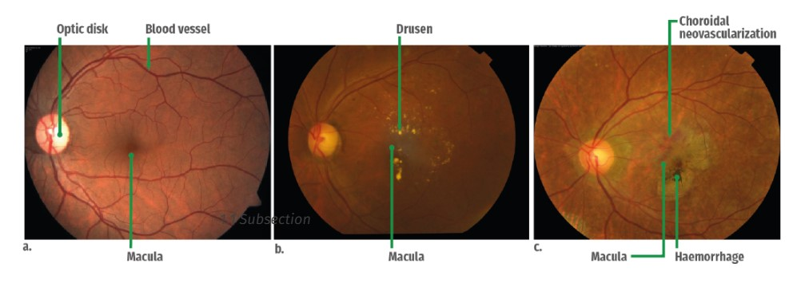**

****

**1.5 Symptoms of Macular Degeneration**

\* less of a clear vision. Your vision may be blurred, and it can be hard to read small text or drive.

\* Black, and opaque areas in the center of your vision.

\* In some rare cases, the poor, or in a different colour vision is also affected.

**1.6 Factors Associated with Macular Degeneration**

Wet armd is one of the most common disease in older people. It causes blindness to the people who has age above 50.

It also from your genes. If someone in your family has it, your risk may be higher.

Smoking, high blood pressure or high cholesterol, obesity, drinking and eating a large quantity of saturated light-colored skin, a woman with pale eyes the color is the most important risk factors.

**1.7 Prevention of Macular Degeneration**

These guidelines will help you to preserve your vision-and improve your health, and some of them can reduce the risk of developing AMD. Even if you have a COMMENT, please keep going, this is a healthy lifestyle:

\* To maintain a healthy weight.

\* A strong nutrition, as well as green, leafy vegetables, yellow and orange fruits, fish and whole grains.

\* Do not smoke.

\* To maintain a normal blood pressure, and the control of other diseases.

\* Exercise regularly, live a healthy lifestyle.

\* A pair of sunglasses and hats when you are outside.

\* Have regular eye examinations and consult your doctor if you notice any changes in the plan

**2. Problem Statement and Proposed Solution**

**2.1 Problem Statement**

The problem of age-related blindness Is major one and persistent in all parts of the world though some are curable does not mean it doesn't come with its own risks The current method of identifying such disease manually is very slow paced, and is prone to human errors, to avoid the errors and to increase the speed of identifying the disease we can take the help of machine learning and image processing techniques.

**2.2 Existing System**

A doctor can usually diagnose a severe macular degeneration( AMD), by examining the eye with an ophthalmoscope (light through a magnifying glass, and the back part of the eye). Retinal damage can be said to be always seen to emerge, even before the symptoms appear. In order to confirm the diagnosis of wet AMD, a doctor could take color images of the retina, or to make a fluorescent angiography. Optical coherence tomography, an imaging study, it can often help in the diagnosis of wet AMD and to evaluate how well a person is responding to treatment. This is a very time-consuming process, and one I'm sure of it.

**2.3 Proposed Solution**

**2.3.1 Convolution Neural Network**

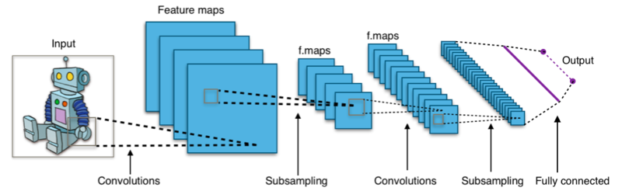

**Figure 3. CNN Layers**

Cnn(Convolution neural network) is made up of different layers of neurons. Artificial neurons, a hard imitation in their organic opposite number, it calculate the sum of the weights of more than one inputs and outputs an activation cost.

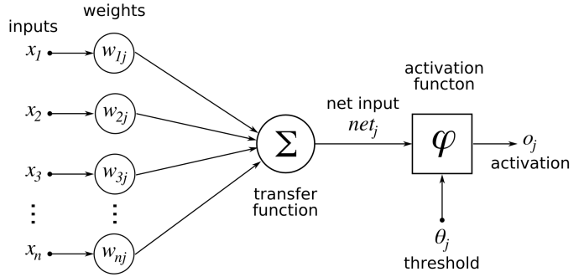

**Figure 4. Basic structure of artificial neural network**

Initially, each neuron has random weight associated with it.each pixel value of the image inserted to neuron and some process takes place in it.

While you're in the convnet image, each of the layers, which will create a much more active on map. To activate the map to check the corresponding image features. Each neuron takes, as well as in the pixel region, thereby increasing their colour values, by means of its own weight, generalizes its values by means of a characteristic function.

The first (or the rear section) layer of the cnn, it will usually have to disclose the essential features, such as horizontal, vertical, or diagonal edges. The output of the first layer is fed to both the next level, which will extract more complex features and functions, combined with the angles and the edge of the combinations. At the very least, when you are moving through the deep convoluted neural swimming pool, a layer, they begin to discover a higher level of the item, along with its elements and additional items.

The operation of multiplying the pixel values of the weights and the sum of them is known as "convolution," (hence the name "convolutional neural network"). A Cnn typically consist of multiple convolution layers, but in addition, it contains other elements. In the last cnn layer is the layer level, that is, the last convolution layer is taken as the input source

Basically, the whole of the activation map of the last convolutional layer and classification layer, resulting in a hard and fast the confidence score values (0 and 1) to determine how likely it is that it is "class". as an example, when there is a convnet detecting armd wet amd, dry amd, is to remove the last layer, which makes it possible to insert an image containing

One of the most hard situations involved in the development of the cnn is to correct the weights of individual neurons, the use of suitable photo-snapping capabilities. The method for the determination of these weights is known as a" training " a neural network.

In the beginning, CNN, starting with random weights. At any stage of the training, the developers provide a neural network with a large number of pictures to be provided with appropriate training ). Convnet processes, each of the picture, with its random values, and then compare it to its ways, exactly, is the image tag. If the output of the network, which does not fit in with the tag—this could be the case in the very beginning of the process of learning is that small weight adjustments in the nerve cells, so that the next time it sees the same image, it predicts the image accurately.

Corrections are made by means of a method which is otherwise known as the backpropogation (or backprop). In fact, in any other manner of distribution that optimizes the tuning of methods and makes it easier for developers to decide what is the unit of measure that is to be adjusted, instead of making random changes.

All of you, all of the data for training, which is called the "epoch". convnet, passing through several eras, at some point in the training process and adapting to its weight and in a small amount. For each period, the neural network will be a bit better, the classification and the training points. As before, to improve, to change it, as it gives the scales turn out to be less. Sooner or later, the network's "convergence", which means that, in principle, is it going to be as effective as possible.

After the training of the cnn, it's a test in the test dataset in order to find it, to be exact. The test dataset is a collection of tagged images that are not part of the training of every image convnet, and the output is compared to the real-tagged image. In fact, the technology, the collection of information, evaluating the way in which it is desirable to have a neural network is as a result of the classification is a photo that has not been seen in the past.

if a cnn network predicts accurately on training data, but fails miserably at testing data, this occurs when the internal training is not sufficiently different, or when the convnet have been many periods of the training data set.

The achievement of convolutional neural networks is mainly due to the large amounts of data that has been developed over the last decade or so. Imagenet, the competition, the very beginning of this newsletter, the information, the release of the information to be collected in more than 14 million categorized photos. The second, more specific data is available, including mnist, a database of 70,000 handwritten digit images.

it is not compulsory to train convolutional neural networks of tens of millions of photos to. In many cases, you can use a trained model, Microsoft alexnet or resnet, and the proper build, the more of it than any other major specialized software. This practice is known as transfer learning, the neural network is retrained with a small set of new examples.

**2.3.2 Inception V3**

Inception v3 is a cnn, which is used for image analysis and object detection and It is also called as Googlenet. It's far the 1/3 edition of google's inception convolutional neural network, it is introduced during the Imagenet Recognition event. Imagenet is a database consists of millions of images. Inception is trained on this database. so,its accuracy is better when compared with other cnn models. Inception v3 is used for object detection. One such use is in life sciences, where it aids in the research of Leukemia.

The architecture of an Inception v3 network is progressively built, step-by-step, as explained below:

**1.Inception v3 model uses very less computer resources. It uses a method called factorizing convolution, which decreases the parameters in the model.it also makes the model efficient.**

**2.In this step we are decreasing the bigger convolutions into smaller convolutions, this helps to train the model faster. if we take a 5\*5, which has 25 parameters. we can replace it with 3\*3 filters which takes 18 parameters.**

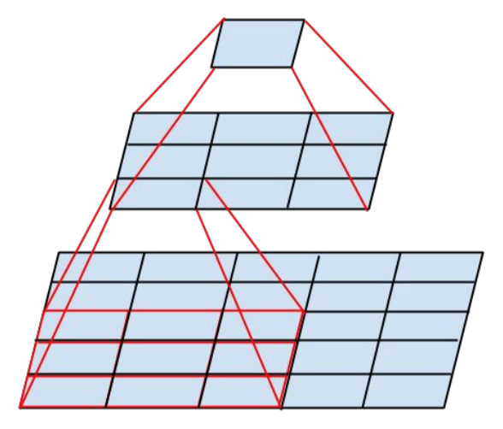

**Figure 5. 3x3 Filters**

From the above fig we see a 3x3 convolution, and also fully connected layer below it.we already know that same weight can be shared between 3\*3 convolutions ,the computation values can be reduced

**3.** A 5 × 5 convolution could be replaced by a 1 × 5 convolution followed by a 5 × 1 convolution. If a 5× 5 convolution is replaced by a 2 × 2 convolution, the number of parameters would be slightly higher than the asymmetric convolution proposed.

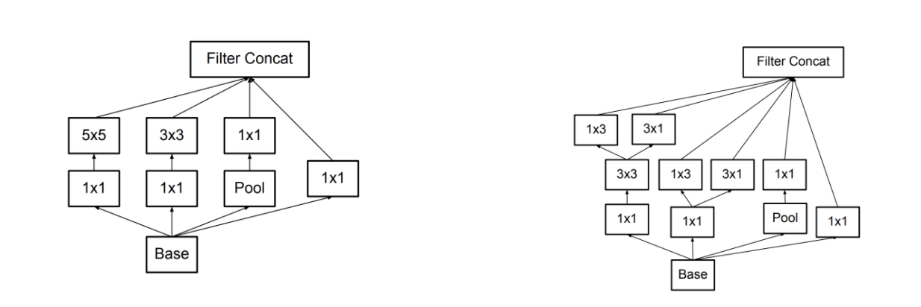

**Figure 6. 5x5 Convolution**

**4.**  In this step we can place a small cnn between layers during training, and the loss is added to the Inception. auxilary classifiers makes the deeper and makes calculations complex. In inception v3 it acts as a regulizer.

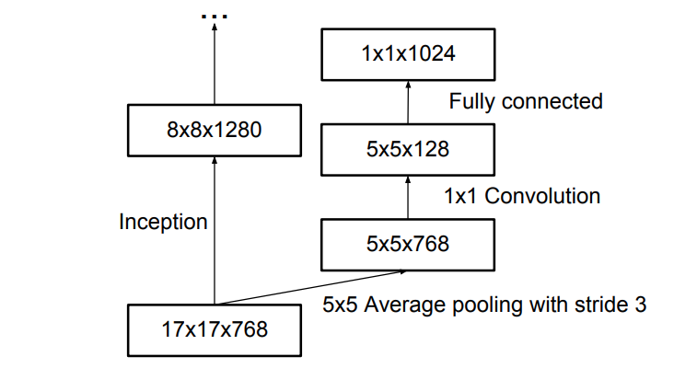

**Figure 7. Auxilary Regulizer**

**5.In this step we will do grid reduction,it is generally done through different pooling methods.this method is mostly used to reduce the bottleneck problem.**

the above concepts are merged into the final architecture.

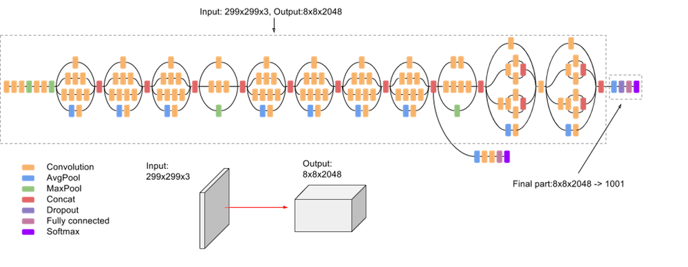

**Figure 8: Inception V3 diagram**

**2.3.3 Transfer Learning**

* It is one of the popular ml method to achieve better accuracy,In this method a model which is already trained in large datatasets,is used.this model is again trained on our dataset,so that it is able to predict our result.
* This method is using vastly now a days.I reduces training time of the model and also gives better results when compared with other pretrained models.this model can be modified according to our needs.
* Example:
  + Oxford VGG Model
  + Google Inception Model
  + Microsoft ResNet Model

**Flask:**

Flask is a web framework written in python. It is identified as a micro-framework, since it is no longer required, unique hardware, or in a library. It does not have a high level of database abstraction, form validation, or any other features that are available in the library, on the third of the holidays does not offer unusual functionality. However, it is going to help you out with the add-ons which can add to the benefit of, the capacity of which they would be applied in theflask itself. In order to extend the existing object-relational mappers, form validation, processing, denial of service, various open authentication technologies and several common hardware-related context.

The flask was created by Armin Ronacher of pocoo, the world of python development organization, 2004. [6] According to the Ronagher, Ideas, and became the first funny story about an April fool's joke that was popular enough to turn on the gravity of the municipal.[7][8][9] this is known as a bottle of the frame. When the Ronacher and Georg Brandl, created the machinery for making bulletin boards, write in python, the pocoo, the task was developed by the werkzeug and jinja. In April of 2016, in pocoo the crew was disbanded, and the improvement of the flasks and tubes, the library includes many of the new uses of pallets.

It is very popular among python developers. In October 2020, it was ranked # 2 on github including python, net development platforms, and the best one, however, is on the back of django, [13] and was recognized as the best and most popular network in python-builders in the survey 2018, the framework programme for research.

**3. Literature Survey**

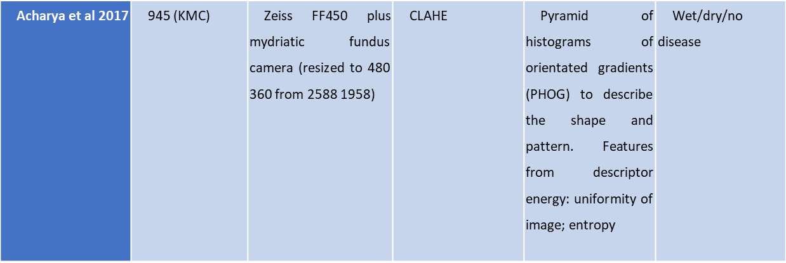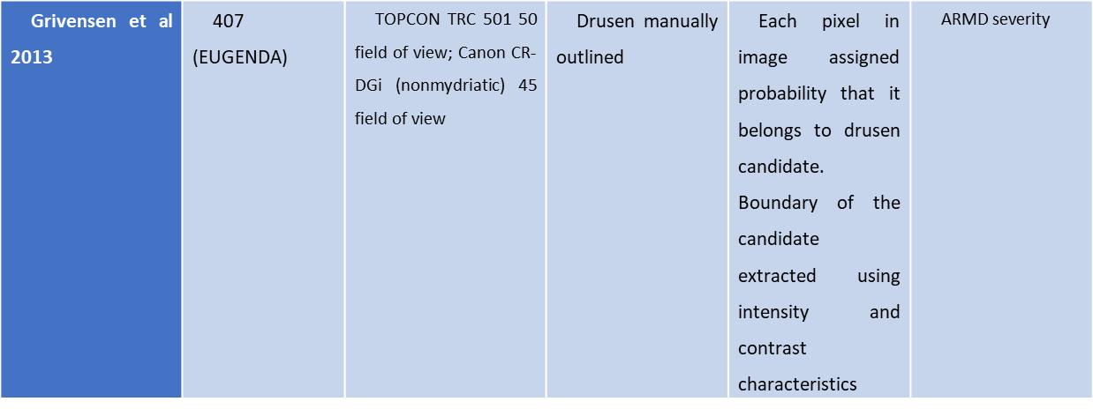

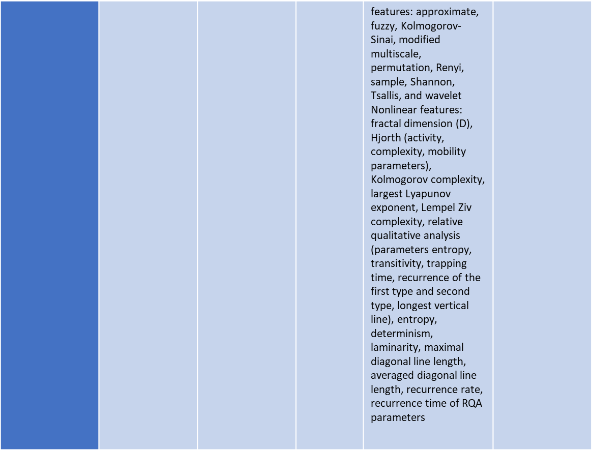

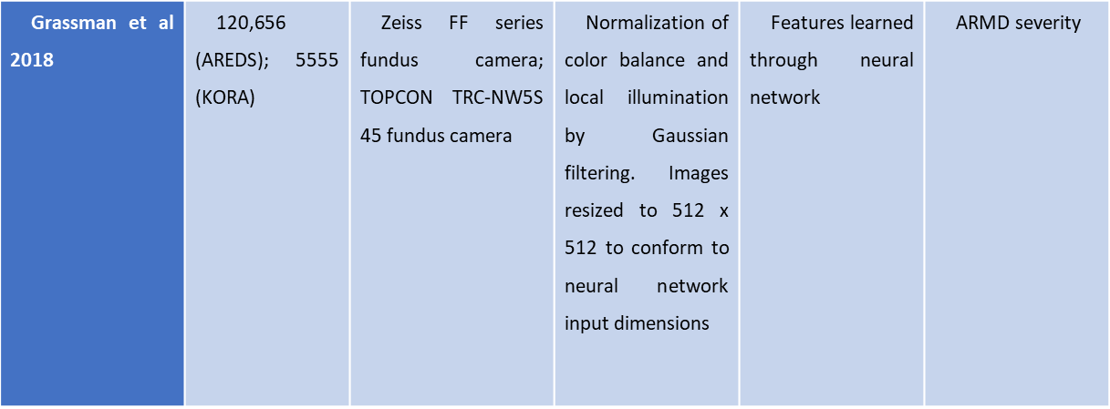

**3.1 Literature survey challenges**

* Most of the papers discussed above had the challenge of finding a robust method to detect and classify the drusen of a fundus image.
* There limitations included a small data set
* The contrast in the fundus image that made it hard to identify the area of interest within the image.
* Classification of images accurately for images belonging to different gender and race.
* Prepossessing methods were made use of to adjust the images to a standard size and contrast for the algorithm to work on.

**4. Architecture and Design**

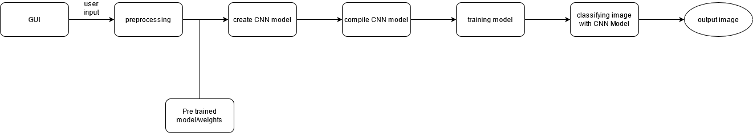

**Figure 9. Data Flow Diagram**

**Graphical User Interface:**

The graphical user interface, it will meet the quality of the component design, software, tool, provides users with the ability to carefully use computers and other electronic devices, with the precise manipulation of the graphical characters of the aşağıdakılarla to sign up, such as buttons and switches, the bars, the windows, icons, menus, instructions, and the unity of the mouse's guide. In many ways, to cut the edges of the consumer, that point on the touch screen, and to be able to play the sound. The default programming of the mobile computers are compatible with the example, the version of the view-controller software.

The principles for building a graphical user interface in accordance with a model of the software of the controller in the model-view-whatever it is that's happening, the presentation of the data, a user's information to be presented, leads to a platform where a user to view the operations that can be performed, but does not require the input of a command. The user can interact with the help of information technology, visual widgets that are designed to be restored, according to the type of information they store, and in favour of the measures that are required in order to carry out the user's personal data.

**4.2 Pre-processing**

Pre-processing common working name and images are always the lowest output rate - both input and output are dynamic images. These thumbnail images are of the same type of identica because the actual data is embedded in the sensor, with a solid image that is usually represented by a matrix of image performance (light) values. The purpose of pre-processing is the development of image facts that suppress undesirable distortions or complete other sensitive image functions in the same processing, although geometric variations of images (eG Rotation, measurement, translation) are distinguished between pre-processing techniques here due to the fact that similar techniques are used. Pre-image processing methods are divided into four categories according to the pixel dimension used to calculate the brightness of a brand new pixel. It deals with pixel light transitions, describes geometric transitions, looks at the advanced techniques that use your local pixel used and briefly describes image restoration that requires information about the complete image.

**4.3 Pretrained Model Weight**

Weights control a signal (or connecting force) between two neurons. In other words, weight determines which quality influences the output of the output. Biases, which are permanent, are additional inputs to the next layer that can always have a value of 1.

**4.4 Create a CNN model**

The MNIST database is easily provided to us as part of the Camera Library, so that we can easily upload the database.

**4.5 Compile CNN model**

After that we merge CNN using the merger function. This function expects three parameters: optimizer, loss function, hence performance metrics. The optimizer is the gradient descent algorithm we will use. We use the binary\_crossentropy loss function because we do binary options.

**4.6 Training model**

Database training model used to train ML algorithm. It contains sample output data so the corresponding sets of input data have an impact on the output. There are several types of machine learning models, of which the best are supervised and uneducated.

Supervised learning can occur when training data contains input and output values. Each set of information with the expected input and output is called a management signal. The training was completed and supported by the deviation of the analyzed outcome from the written result when the input was inserted into the model.

Unattended reading involves inserting patterns within data. Additional information is used to measure patterns or collections. This is also a repetition process that improves accuracy that supports the combination of patterns or expected clusters. There is no reference dataset in this way.

**4.7 Classify images with CNN**

Before we train the cnn model, permission to build a simple fully connected neural database community. Important steps for modeling image classification using the neural network are:

• Fill in the image size to 1D (width pixels x pixels height).

• Normally calculate picture pixels (split by 255).

• One-Hot Encode column categories.

• Build a construction model (Sequence) with dense layers.

• Train the model and make predictions.

Here's how to build a MNIST neural network model.

**4.8 Output image**

Here we will find a picture of the discharge where we will show the person how much they have touched and what type of disease ARMD is.

**5. Implementation**

**5.1 Development Requirements**

**5.1.1 Hardware Requirements**

|  |  |  |
| --- | --- | --- |
| PROCESSOR | : | Intel i5 |
| RAM | : | 4GB |
| HARD DISK | : | 16GB |

**5.1.2 Software Requirements**

|  |  |  |
| --- | --- | --- |
| OPERATING SYSTEM | : | Linux/Windows |
| BACK-END | : | Python3 |
| OTHER BACKEND LIBRARIES | : | Keras, tensorflow, dicom |
| FRAMEWORKS | : | Flask |
| FRONT-END | : | HTML, CSS, JavaScript |
| OTHER REQUIREMENTS | : | HTML5 Enabled browser |

**5.2 LOSS**

The **Loss Function** is one of the important components of Neural Networks. **Loss** is nothing but a prediction error of Neural Net. And the method to calculate the loss is called Loss Function.

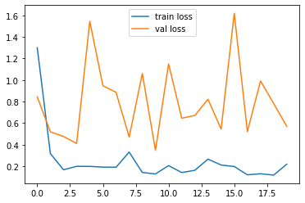

**Fig 10. Training and validation loss graph1**

Training loss- loss on training data chances of under fitting.

Validation loss- loss on validation data chances of over fitting.

**5.3 ACCURACY**

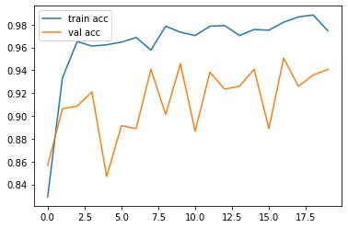

**Fig 11. Training and validation loss graph2**

Training accuracy- the accuracy with which the model predicts seen data.

Validation accuracy- the accuracy with which the model predicts unseen data.

* Training loss and validation loss are measurement of the of deviation of prediction from the actual label of the data.
* Training loss increases as the prediction moves away from the actual label and decreases as the model predicts the class increasingly better.
* Training loss and validation loss play an important role in assessing the model as training loss and validation loss are used to detect over fitting and under fitting of data.
* Training loss is the loss that happens on the training data and validation loss is the loss that happens on the validation data.

• If the validation loss is>the training loss, then there is a model, according to the C.

• If the damage to the education and training> > checking for injuries, as the model in the assembly.

* + The Optimal minimization and error handling, in order to get better results.
  + The neural network is trained by means of an optimization process, which requires a loss function in order to compute the model error.
  + Most likely to provide a basis for selecting the training, the loss function of neural networks, and models of the general population.
  + Cross-entropy, and the root-mean-square error, there are two main types of loss functions that can be used in the training of the neural network models.
* The neural network is trained using stochastic gradient descent, which is necessary in order to design and build a model that is selected, a simple loss of function.
* For many, loss of features, they have to be solved, and it can be difficult to understand, or to quit, or, it may be that such a loss function plays a role in the neural network training as well.

**6. RESULT**

The model after training for 20 epochs gave an accuracy of 94% this was achieved with the help of pretrained models (inception v3 on ImageNet weights) the model was Able to predict and classify the image into the correct class as ‘NORMAL’, ‘DRY ARMD’ and ‘WET ARMD’

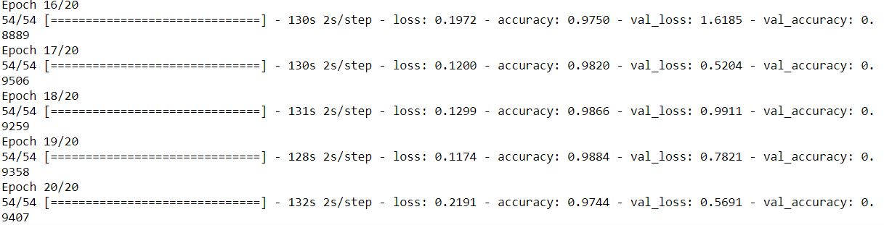

**Figure 12. Epochs with Loss and Accuracy**

The model has 20 epochs in each epoch of iteration the accuracy is maximised and loss is minimised.

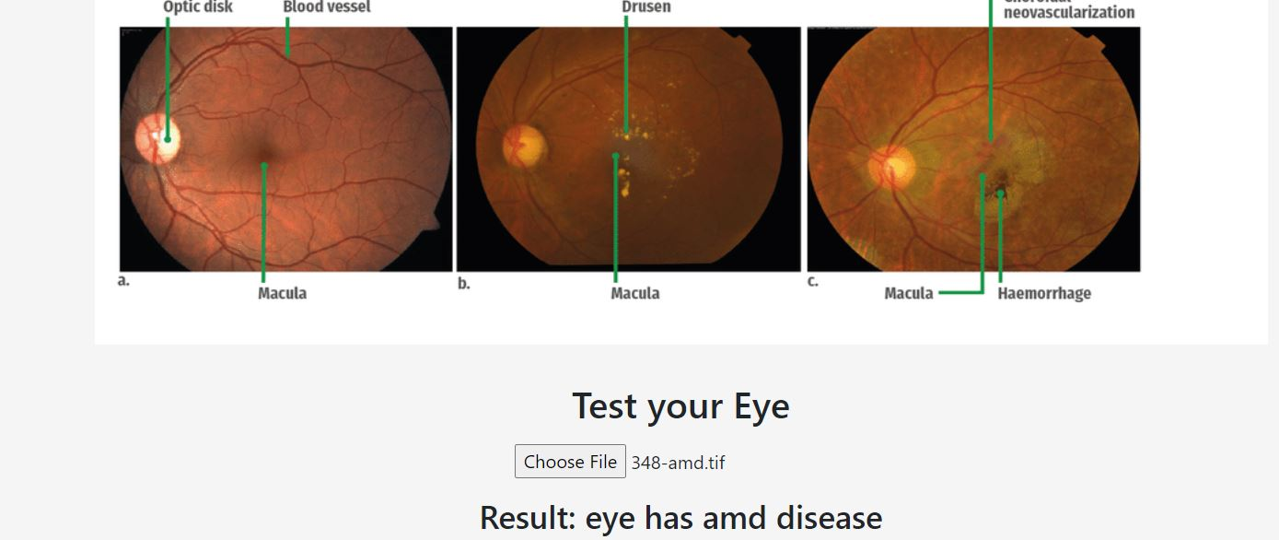

**Figure 13. Eye classified has AMD**

Here in this above fig. a image is taken from the user input and Result is classified as eye has ARMD disease.

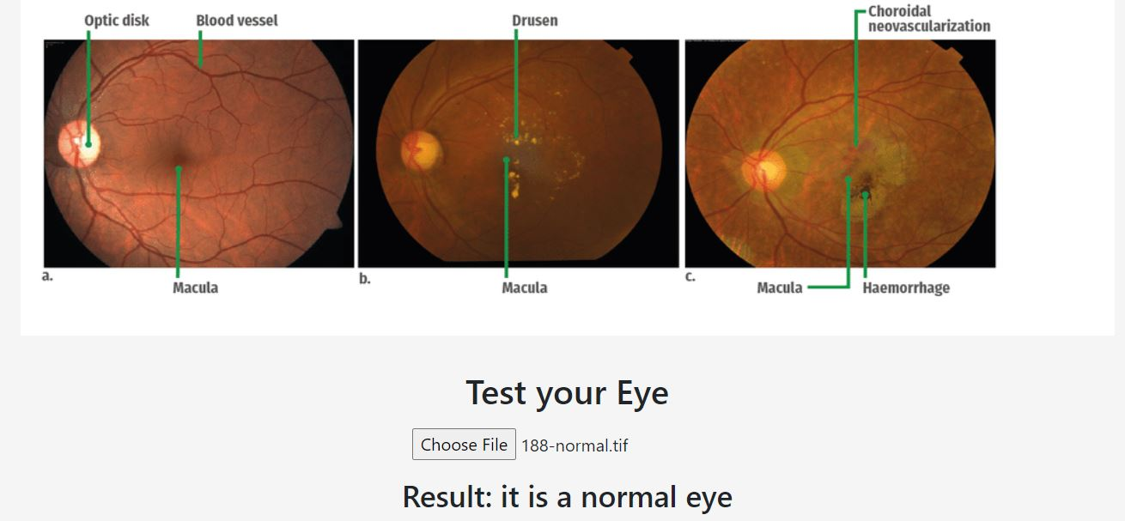

**Figure 14. Eye classified has Normal**

Here in this above fig. a image is taken from the user input and Result is classified as eye has Normal ARMD.

**7. CONCLUTION**

From the above we conclude that classification of image into normal dry and wet ARMD was achieved with 94% accuracy and was able to classify into three classes furthermore we have tried different models like resnet and inception v3 to classify the images. Inception v3 model got better accuracy (94%) when compared with other model. Which yielded lower accuracies for future enhancements we would like to be able to train the model so that it can predict the degree of ARMD present in any class of the disease and can give a better picture as to how affected you are by the disease.

**8. REFERENCES**

1.A. Bosch, A. Zisserman, X. Munoz, Representing shape with a spatial pyramid kernel, Proceedings of the 6thACM International Conference on Image and Video Retrieval (2007) 410-408.

2.A. Gelman, Analysis of variance –why it is more important than ever, The Annals of Statistics 33 (1) (2005) 1-53.

3.A. J. Smola, B. Schölkopf, K. R. Müller, The connection between regularization operators and support vector kernels, Neural Networks 11 (1998) 637-649.

4.A. Lempel, J. Ziv, On the complexity of finite sequences, IEEE Transactions on Information Theory 22 (1) (1976) 75-81.

5.M. Haddrill, C. Slonim, All About Vision, What is age-related macular degeneration? <http://www.allaboutvision.com/conditions/amd.htm>.

6.A. N. Kolmogorov, New metric invariant of transitive dynamical systems and endomorphisms of Lebesgue spaces, Doklady of Russian Academy of Sciences 119 (1958) 861-864.

7.A. Renyi, On measures of entropy and information, Fourth Berkeley Symposium 547-561.27

8.A. Unler, A. Murat, A discrete particle swarm optimization method for feature selection in binary classification problems, European Journal of Operational Research 206 (3) (2010)

9.A. V. Oppenheim, G. C. Verghese, Signals, systems, and inference, Lecture Notes in Introduction to Communication, Control, and Signal Processing (2010).

10.B. B. Mandelbrot, Geometry of nature, Freeman, San Francisco (1983).

11.B. Hjorth, EEG analysis based on time domain properties, Electroencephalography and Clinical Neurophysiology (1970).

12.B. Kosko, Fuzzy entropy and conditioning, Information Sciences 40 (2) (1986) 165- 174.

13.C. Agurto, E. S. Barriga, V. Murray, S. Nemeth, R. Crammer, W. Bauman, G. Zamora, M. S. Pattichis, P. Soliz, Automatic detection of diabetic retinopathy and agerelated macular degeneration in digital fundus images, Investigative Ophthalmology, and Visual Science 52 (8) (2011) 5862-5871.

14.C. Bandt, B. Pompe, Permutation entropy: a natural complexity measure for time series, Physical Review Letters 88 (17) (2002).

15.C. E. Shannon, A mathematical theory of communication, The Bell System Technical Journal 27 (1948) 379-423, 623-656.

16.C. Köse, U. Şevik, O. Gençalioğlu, Automatic segmentation of age-related macular degeneration in retinal fundus images, Computers in Biology and Medicine 38 (2008) (5) 611-619.

17.C. Köse, U. Şevik, O. Gençalioğlu, C. İkibaş, T. Kayikiçioğlu, A statistical segmentation method for measuring age-related macular degeneration in retinal fundus images, Journal of Medical Systems 34 (1) (2010) 1-13.

18.C. L. Webber, J. P. Zbilut, Dynamical assessment of physiological systems and states using recurrence plot strategies, Journal of Applied Physiology 76 (1994) 965- 973.

19.C. Tsallis, Possible generalization of Boltzmann-Gibbs statistics, Journal of Statistical Physics 52 (1988).

20. G. C. Brown, M. M. Brown, S. Sharma, J. D. Stein, Z. Roth, J. Campanella, G. R. Beauchamp, The burden of age-related macular degeneration: a value-based medicine analysis, Transactions of the American Ophthalmological Society 103 (2005) 173-18

21. H. He, E. A. Garcia, Learning from imbalanced data, IEEE Transactions on Knowledge and Data Engineering 21 (9) (2009) 1263-1284.

22. H. He, Y. Bai, E. A. Garcia, S. Li, ADASYN: adaptive synthetic sampling approach for imbalanced learning, IEEE International Joint Conference on Neural Networks (2008) 1322-1328.

23. H. R. Coleman, C. C. Chan, F. L. F. Ill, E. Y. Chew, Age-related macular degeneration, Lancet 372 (9652) (2008) 1835-1845.

24. H. S. Lei, V. Govindaraju, Half-against-half multi-class support vector machines, In N. C. Oza, R. Polikar, J. Kittler, F. Roli, Multiple Classifier Systems, Multiple Classifier Systems, Lecture Notes in Computer Science 3541 (2005) 156-164.

25. I. A. Gheyas, L. S. Smith, Feature subset selection in large dimensionality domains, Pattern Recognition 43 (2010) 5-13.

26. J. B. Alonso, F. Diaz-de-Maria, C. M. Travieso, M. A. Ferrer, Using nonlinear features for voice disorder detection, International Speech Communication Association Tutorial and Research Workshop on Non-linear Speech Processing (2005) 94-106.

27. J. Kennedy, R. C. Eberhart, Particle swarm optimization, Proceedings of IEEE International Conference on Neural Networks (1995) 1942-1948.

28. J. P. Zbilut, C. L. Webber, Embeddings and delays as derived from quantification of recurrence plots, Physics Letter A 171 (1992) 199-203.

29. J. S. Richman, J. R. Moorman, Physiological time-series analysis using approximate entropy and sample entropy, American Journal of Physiology - Heart and Circulatory Physiology 278 (6) (2000) 2039-2049.

30. L. Yaeger, Intro to genetic algorithms, Lecture 3, Artificial Life as an Approach to Artificial Intelligence, Indiana University.

**9. Appendix**

Source code or Program